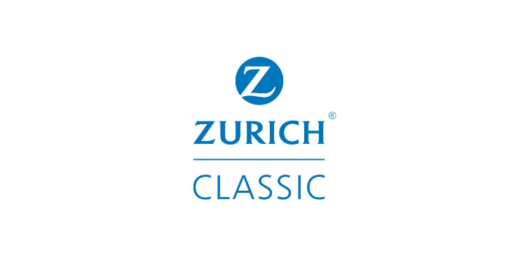

2024 Zurich Classic of New Orleans Message Document

- 20 years: The Zurich Classic of New Orleans is the only official FedExCup event to feature a two-player team format, with 160 players (80 teams) who play Four-Ball (first and third rounds) and Foursomes (second and final rounds). Each player on the winning team will receive 400 FedExCup points, $1,286,050 and a two-year exemption on the PGA TOUR (through 2026). An annual TOUR stop since 1958, the Zurich Classic of New Orleans moved to the team format in 2017. The 2024 tournament recognizes important milestones in its history:
  - 20 years of Zurich title sponsorship: Zurich Insurance Group, a leading multi-line insurer serving more than 55 million customers – both individuals and businesses – in more than 210 countries and territories, has sponsored the event since 2005. This year is the 19th playing of the event due to a one-year hiatus in 2020 (COVID-19) and the 2006 Zurich Classic was one of the first professional sporting events to return to the city following Hurricane Katrina. In its 20-year history with Zurich at the helm, the tournament has generated more than $645 million in economic activity for the New Orleans community and has raised more than $30 million for charitable organizations, supporting 200,000 children in need annually. Last year, the Classic set a record with more than $2.8 million in charitable donations. Over the past 20 years, the Zurich Classic has raised nearly $2 million in support of St. Michael Special School and nearly $600,000 for Blessings in a Backpack.
  - 20 years at TPC Louisiana: The tournament moved to its present-day home in 2005 and outside of 2006 following Hurricane Katrina when the event returned to English Turn, TPC Louisiana has hosted every Zurich Classic of New Orleans since (this is the 18th playing at TPC Louisiana due to 2006/Hurricane Katrina and 2020/COVID-19).
- Teams: The 2024 field features teams of familiar favorites, new match-ups and three sets of brothers.
  - Familiar Favorites: Defending champions Nick Hardy and Davis Riley return after each earning their maiden PGA TOUR victory in 2023. 2022 champions and best friends Patrick Cantlay and Xander Schauffele will each compete for the third consecutive week following the Masters – where Schauffele finished 8th – and the RBC Heritage – where Cantlay finished T3. Pairings of Charley Hoffman and Nick Watney and Kevin Tway and Kelly Kraft are the only two pairs who have competed together in all six editions of the team format.
  - New Match-ups: World No. 2 Rory McIlroy will make his tournament debut alongside fellow countryman Shane Lowry who will make his fifth start in the event. Zurich ambassador Billy Horschel, who won last week’s Corales Puntacana Championship, will partner with fellow Florida Gator Tyson Alexander for the first time. Horschel is the only player to win both in the individual and team format (2013, 2018).
  - Brothers: There are three sets of brothers competing in the 2024 event, including Matt and Alex Fitzpatrick, whose tournament debut in 2023 was documented in Season Two of Netflix’s Full Swing. Denmark’s twins Nicolai and Rasmus Højgaard will team up for the first time. Nicolai, who earned his TOUR card for the 2024 season via the Top-125 non-member FedExCup points, played in the 2023 Zurich Classic, while Rasmus competed in 2021. Twins and PGA TOUR rookies Parker and Pierceson Coody, who earned their TOUR cards via the 2023 Korn Ferry Tour, will make their tournament debut. Parker enters the week off his first career top-10 on TOUR at last week’s Corales Puntacana Championship (finished T6). Their grandfather, Charles Coody, made 22 starts in the Zurich Classic with a career-best fifth-place finish in 1971, just two starts after he won the Masters Tournament.
- Aon Next 10 / Aon Swing 5: Two starts remain until the next Signature Event, the Wells Fargo Championship. The top 10 FedExCup points earners through THE CJ CUP Byron Nelson not otherwise exempt will earn spots via the Aon Next 10. The top five FedExCup points earners in the Corales Puntacana Championship, Zurich Classic of New Orleans and THE CJ CUP Byron Nelson will earn spots via the Aon Swing 5. With his victory at the Corales Puntacana Championship, Billy Horschel moved to the top of the Aon Swing 5 category, on pace for his first Signature Event start of 2024. (Reminder: Winners of Additional Events are not guaranteed access to Signature Events, but will likely qualify for the next Signature Event via the Aon Swing 5)

