EUROVISION SERVICES TECHNICAL NOTICE

PGA TOUR - International Distribution Asia

07 June 2022

Version 3.1

CONTENTS
INTRODUCTION 3
SATELLITE ASIASAT 5 3
SATELLITE RECEPTION 4
MODULATION SCHEME (NS4 – C9V until 27.06.22) 5
MODULATION SCHEME (NS4 -HMcrypt– C11V as of 23.06.22) 6
MULTIPLEX PLATFORM (C9V until 27.06.22) 8
MULTIPLEX PLATFORM (C11V MUX as of 23.06.22) 8
TYPICAL RECEPTION INSTALLATION 9

INTRODUCTION
Eurovision Services is establishing a permanent satellite multiplex to distribute the PGA TOUR content across Asia. This satellite multiplex will enhance and facilitate broadcasters' technical ability to access PGA TOUR content more easily, as it will be permanently available throughout PGA TOUR Tournament event days.

In order to provide a highly efficient service to Asia, Eurovision services will use the NS4 modulation scheme for this permanent satellite multiplex. The carrier parameters are optimised to achieve higher spectrum efficiency and an improved C/N margin on the receive side.

The Eurovision Services will set up a permanent satellite multiplex, which will operate in NS4 mode to the Asiasat 5 transponder C9V until 27. June 2022 and operate in NS4 mode encrypted in HMcrypt to the Asiasat 5 transponder C11V as of 23. June 2022. Between 23. June and 27. June Eurovision Services will operate in simulcast on both transponders C9V and C11V.

SATELLITE ASIASAT 5

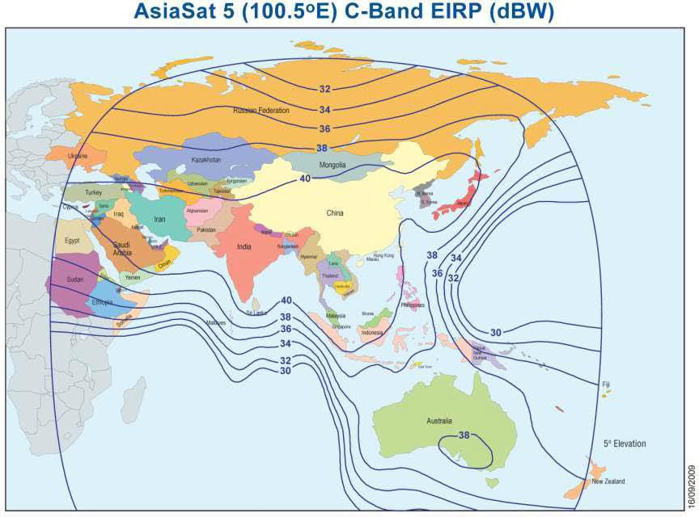

Until 27. June 2022

SATELLITE | ASIASAT 5
ORBITAL POSITION | 100.5 DEG E
TRANSPONDER | C9V
DOWNLINK FREQUENCY | 3980,00 (POLARIZATION V)
BANDWIDTH | 36 MHZ

As of 23. June 2022

SATELLITE | ASIASAT 5
ORBITAL POSITION | 100.5 DEG E
TRANSPONDER | C11V
DOWNLINK FREQUENCY | 4080,00 (POLARIZATION V)
BANDWIDTH | 72 MHZ

SATELLITE RECEPTION

Antenna Requirements

ANTENNA DIAMETER | 3.0M
GAIN RX | BETTER THAN 39.8 DBI
VSWR RX | BETTER THAN 1.5:1
OPERATING FREQUENCY | 3.625 - 4.200 GHZ
POLARIZATION | LINEAR VERTICAL
ANTENNA NOISE TEMPERATURE (AT ELEVATION 30 DEG) | 31DEGK
ISOLATION PORT-TO-PORT RX | BETTER THAN 65DB
LNB PLL TYPE | WITH L.O. STABILITY BETTER THAN  +/- 25 KHZ

ANTENNA DIAMETER | 4.5M
GAIN RX | BETTER THAN 42.8DBI
VSWR RX | BETTER THAN 1.5:1
OPERATING FREQUENCY | 3.625 - 4.200 GHZ
POLARIZATION | LINEAR VERTICAL
ANTENNA NOISE TEMPERATURE (AT ELEVATION 30 DEG) | 31DEGK
ISOLATION PORT-TO-PORT RX | BETTER THAN 65DB
LNB PLL TYPE | WITH L.O. STABILITY BETTER THAN  +/- 25 KHZ

Equipment
In order to receive the signal from the satellite, each receiving Broadcaster in Asia will need to install NS4 demodulators (NS2000) (with DRM license for HMcrypt for C11V MUX reception) and MPEG4 compatible decoders.
For any questions regarding NS4 modulation, please contact:
demodsupport@eurovision.net

The receiving broadcasters are invited to make contact the relevant manufacturers to purchase directly the adequate equipment.

MODULATION SCHEME (NS4 – C9V until 27.06.22)

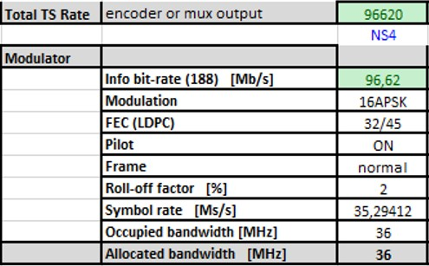
The NS2000 demodulator needs to be configured accordingly. Please see screenshot attached

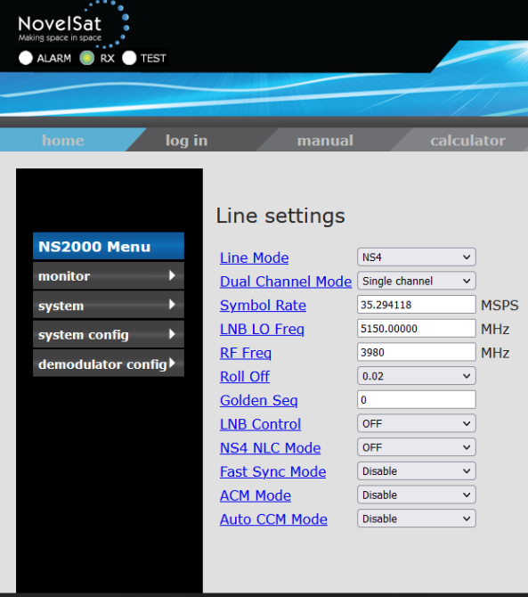

MODULATION SCHEME (NS4 -HMcrypt– C11V as of 23.06.22)

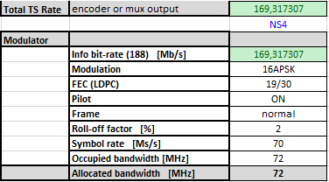
The NS2000 demodulator needs to be configured accordingly. Please see screenshot attached
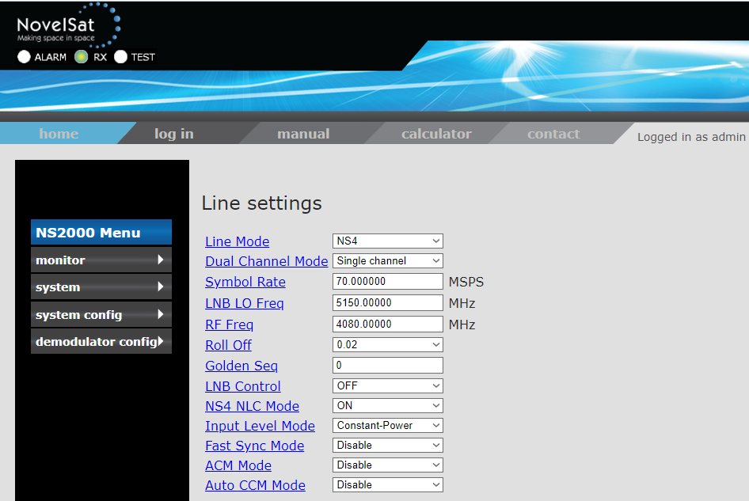

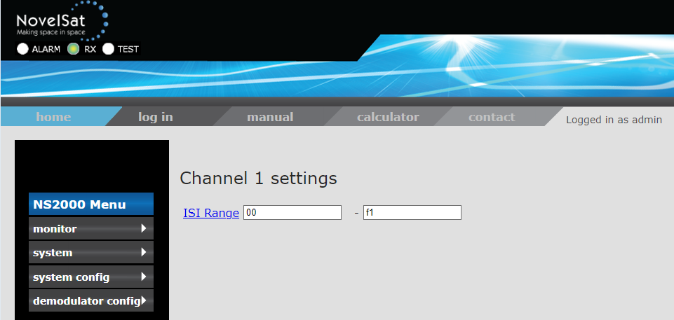

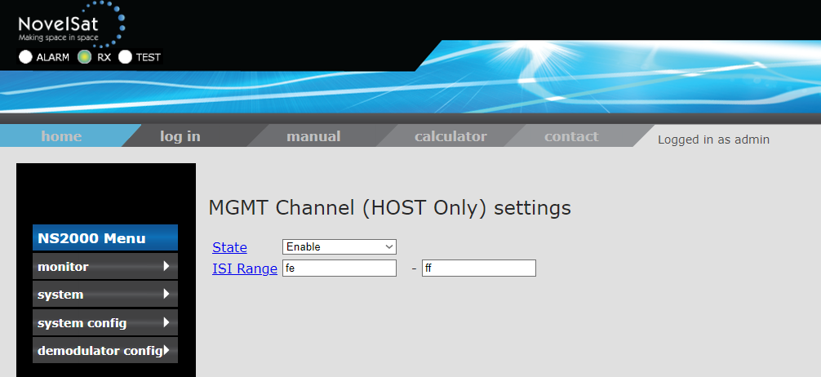

MULTIPLEX PLATFORM (C9V until 27.06.22)

The total bit rate allows to accommodate 6 channels of MPEG4 encoded streams individually encrypted. The mode used for given service will be communicated for each individual service separately with the Eurovision Services Synopsis

Following encoding profiles are planned to be used:

Video
HD_16 Profile PGA - MPEG-4 AVC/H.264 (4:2:0 8-bit) - HD

Audio
Stereo - MPEG-1 Layer II

MULTIPLEX PLATFORM (C11V MUX as of 23.06.22)

Eurovision Services uses the Hypermux-1 (HM1) platform for the distribution of premium content in Asia via the Asiasat-5 satellite, transponder C11V with encryption HMcrypt. The multiplex platform used allows for 6 channels of MPEG4 encoded streams (service 13 to service 18) to be individually encrypted (BISS) for PGA Tour. The mode used for each service is communicated separately with the Eurovision Services Synopsis.

Following services are used in the framework of PGA tour:

xxs13 - A - EIF
xxs14 - B - Main Feed / Ftr Grp
xxs15 - C - Marquee Grp / Ftr Grp
xxs16 - D - Ftr Grps / Ftr Hole
xxs17 - E - Ftr Holes / Ftr Hole
xxs18 - F - Champ / Korn Ferry

Following encoding profiles are planned to be used:

Video
HD_16 Profile PGA - MPEG-4 AVC/H.264 (4:2:0 8-bit) - HD

Audio
Stereo - MPEG-1 Layer II

TYPICAL RECEPTION INSTALLATION

NS 2000 – NS4 demodulator - 1
L-band in
ASI out
L-band in
NS 2000 – NS4 demodulator - 2
ASI out
HD-SDI out
IRD/Decoder 1
ASI IN
HD-SDI out
IRD/Decoder 2
ASI IN
HD-SDI out
IRD/Decoder 3
ASI IN
HD-SDI out
IRD/Decoder 4
ASI IN
HD-SDI out
IRD/Decoder 5
ASI IN
HD-SDI out
ASI IN
IRD/Decoder 6
Any number of additional decoders can be
connected

