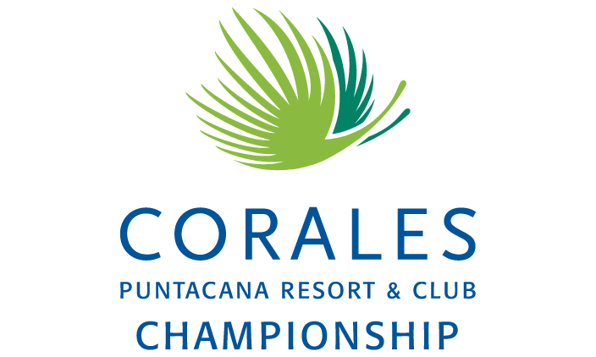

2021 Corales Puntacana Resort & Club Championship Message Document

Things to know about the 2020 Corales Puntacana Resort & Club Championship

- Critical Role: The Corales Puntacana Resort & Club Championship played a critical role in the TOUR’s Return to Golf. After being postponed from March to September 2020, the 2020 Corales Puntacana Resort & Club Championship marked the TOUR’s first international event since the onset of the pandemic, and also saw the return of the Wednesday pro-am, a vital component of a PGA TOUR tournament in driving charitable contributions in the local community.
- 182 days: 182 days marks the time span between the crowning of the 2020 Corales Puntacana Resort & Club Championship winner, Hudson Swafford, and this week’s eventual champion. As one of three events to be played twice during the 2020-21 PGA TOUR “super season” (others: Masters, U.S. Open), the Corales Puntacana Resort & Club Championship is the first event since 1950 to be played twice in the same season.
- Field & FedExCup: After a standalone date in 2020, the Corales Puntacana Resort & Club Championship returns to the week opposite the World Golf Championships-Dell Technologies Match Play, offering 300 FedExCup points. The 2021 field was expanded from 120 to 132 to include a new Korn Ferry Tour category. The top 10 from the Korn Ferry Tour points list following the conclusion of the 2020 Korn Ferry Tour Championship presented by United Leasing & Finance in September gained access into all PGA TOUR additional events in the 2020-21 PGA TOUR Season.
- On-Site Experience: As the on-site experience continues to expand at PGA TOUR events, due to local circumstances, the 2021 Corales Puntacana Resort & Club Championship will not have general spectators in attendance. Instead, 2,000 invited sponsor guests will have access to on-course zones throughout tournament rounds and honorary observers will be allowed inside the ropes.
- Dominican Double: The 2021 event marks the fourth playing of the event, after spending two years on the Korn Ferry Tour. All five winners at Corales Golf Course are in the field this week, including defending champion Hudson Swafford, each looking for a second win in the Dominican Republic.
  - 2020 - Hudson Swafford
  - 2019 - Graeme McDowell
  - 2018 - Brice Garnett
  - 2017 - Nate Lashley (*KFT)
  - 2016 - Dominic Bozzelli (*KFT)
- Embrace the New Normal: Continuing from the 2020 event, the tournament aims to highlight the clean and safe environment Puntacana Resort & Club has created through the resort’s health and safety protocol, “Embrace the New Normal,” which also extends to nearby Punta Cana International Airport. As the most accessible island in the Caribbean, this week’s TOUR event showcases to the world that Punta Cana and the Dominican Republic is safe for travel.

Interview Schedule
Tuesday, March 23
3 p.m. – Hudson Swafford and Charley Hoffman with Groupo Puntacana President & CEO Frank Rainieri/PGA TOUR SVP John Norris/Minister of Tourism David Collado/Tournament Director Manuel Sajour)

Wednesday, March 24
TBD – Danny Willett

