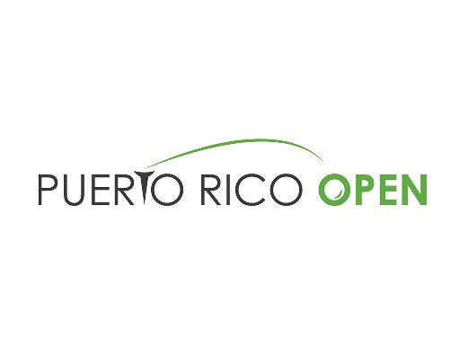

2021 Puerto Rico Open Message Document
Things to know about the Puerto Rico Open
- Grand Reserve Country Club: Since its inception in 2008, the tournament has been held on the same Tom Kite-design par 72. The course has been renamed several times throughout the years, which is now known as Grand Reserve Country Club.
- PGA TOUR golf in Puerto Rico: The 2021 Puerto Rico Open marks the 13th playing of the event (one-year hiatus in 2018 to host charity pro-am after Hurricane Maria) which has been heralded as Puerto Rico’s major professional sporting event. Thanks to the support of title sponsor, the Puerto Rico Tourism Company, the Puerto Rico Open has showcased Puerto Rico as a top destination for golf and vacation to a global audience via the Golf Channel and GOLF TV. Health and safety are a top priority as the Island has responsibly welcomed visitors during the pandemic.
- Springboard to Stardom: The Puerto Rico Open has continually served as a springboard to success on the PGA TOUR, helping elevate the careers of up-and-comers:
  - In 2020, rookie Viktor Hovland won his first PGA TOUR title in dramatic fashion, sinking a 30-foot birdie putt on the 18th hole for victory. Since winning the 2020 Puerto Rico Open, Hovland finished 20th in the 2019-20 FedExCup standings, won his second PGA TOUR title at the 2020 Mayakoba Golf Classic and climbed as high as No. 12 in the Official World Golf Ranking.
  - World No. 15 Tony Finau won his lone TOUR event at the 2016 Puerto Rico Open; since then, Finau has accumulated 44 top-10s, including eight runner-ups – most recently at last week’s The Genesis Invitational when he was defeated in a playoff by Max Homa.
  - Reigning U.S. Open champion Bryson DeChambeau lost in a playoff at the 2017 Puerto Rico Open and went on to win his first PGA TOUR title later that season; he now has seven titles.
  - Past sponsor exemptions include Jordan Spieth (2013) and Brooks Koepka (2014). Spieth earned Special Temporary Membership soon after his runner-up finish in 2013 and was named PGA TOUR Rookie of the Year; He has since won the FedExCup (2015) and accumulated 11 career PGA TOUR wins; Koepka, currently No. 12 in the OWGR, has eight PGA TOUR wins, including four majors.
  - In his second season on TOUR, Jason Day finished T2 in Puerto Rico, his best finish in his first 39 starts on TOUR; Day has gone on to win 12 times.
  - After finishing runner-up at the 2015 Puerto Rico Open, Emiliano Grillo won the 2015 Safeway Open and was voted PGA TOUR Rookie of the Year.
- With this victory: The Puerto Rico Open provides tremendous opportunity to PGA TOUR players with the winner receiving 300 FedExCup points, a two-year exemption on the PGA TOUR and a spot in THE PLAYERS Championship and other select events.
- Extended field: The 2021 Puerto Rico Open field was expanded from 120 to 132 to include a new Korn Ferry Tour category. The top 10 from the Korn Ferry Tour points list following the conclusion of the 2020 Korn Ferry Tour Championship presented by United Leasing & Finance in September gained access into all PGA TOUR additional events in the 2020-21 PGA TOUR Season. There are eight players in the Puerto Rico Open field via this category:
  - Davis Riley
  - Lee Hodges
  - Taylor Pendrith
  - Brandon Wu
  - Greyson Sigg
  - Mito Pereira
  - Paul Barjon
  - Stephan Jaeger
- First Tee: First Tee – Puerto Rico became an official chapter of First Tee in December 2020, with PGA TOUR player and native Puerto Rican native Rafael Campos serving on the Board and already committing to future support via clinics. Due to COVID-19, chapter programs have not been able to start, but exciting plans are on the horizon in a partnership with TPC Dorado Beach, the YMCA of San Juan and Boys and Girls Club, Isabella Center.
- With this victory: The Puerto Rico Open winner receives 300 FedExCup points, a two-year exemption on the PGA TOUR and an invitation to THE PLAYERS Championship (if not previously eligible) and other select events.

