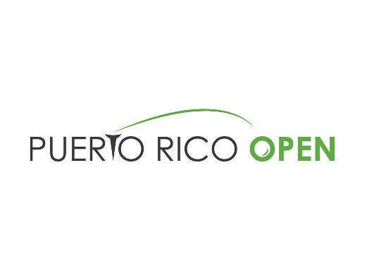

2020 Puerto Rico Open Miscellaneous Information

HOST ORGANIZATION: Puerto Rico Open, LLC (Global Golf Management, Inc.)
David H. Chafey, Tournament Chairman Mike Harmon, Executive Director
Matt Truax, Tournament Director
Pedro Zorilla, Director of Sales
Karen Calvesbert, Director of Operations

TITLE SPONSOR: Puerto Rico Tourism Authority
Wanda Vazquez Garced, Governor of Puerto Rico
Carla Campos, Executive Director, Puerto Rico Tourism Co.
Imaris Arocho, Marketing Director, Puerto Rico Tourism Co.
Brad Dean, Chief Executive Officer, Discover Puerto Rico
Leah Chandler, Chief Marketing Officer, Discover Puerto Rico
Michelle Vilas, Marketing Manager, Discover Puerto Rico

Points of Interest
- The Puerto Rico Open appeals not only to those interested in sports tourism, but also to those looking for a luxury destination. Strengthening the luxury and sports event niche markets is part of the Tourism Company’s strategy to attract and increase high-end tourists’ visits to the island.
- Puerto Rico has been a proud host of the PGA TOUR over the last decade and is excited to host the event in 2020 and 2021. With a one-year hiatus in 2018 to host a charity pro-am for Hurricane Maria recovery, the Puerto Rico Open is back stronger than ever as Puerto Rico’s major professional sporting event.
- he 2020 event is expected to attract more than 25,000 spectators during competition rounds.
- Tournament will be hosting a Junior Clinic on Tuesday with Puerto Rican former world champion professional boxer Miguel Cotto on Tuesday following a successful clinic in 2019 put on with the help of Baseball Hall of Famer Iván Rodríguez.
- Puerto Rico’s vibrant culture, friendly people and diverse scenery make it a top destination in the Caribbean. The island has received numerous accolades as a top travel destination including CNN’s 2020 “10 of the Best Caribbean Islands to Visit,” Forbes’ “US Travel: 25 Best Places to Visit in 2020” and “Five Hottest Places to Travel in 2020 for your Best Vacation,” as well as National Geographic Traveler’s “Cool List for 2020.”
- Note: In early January, Puerto Rico experienced an earthquake that affected the southwest coast of the island. Upon evaluation, the region received minor damage and the island continues to operate normally.

Golf Course
Coco Beach Golf and Country Club experienced minimal damage during the recent earthquakes and its playing condition is expected to be similar to previous years. The Sea Isle 1 Paspalum greens currently have good turf coverage and consistent ball roll. The remainder of the course is also covered with Paspalum, and aside from the isolated presence of bermudagrass, should be in familiar condition. There have been no course changes over the last twelve months.
- The target greenspeed for the event is 11 feet.
- The tees, fairways, and approaches will be mowed at 0.425 inch
- The intermediate rough will be mowed at 0.750 inches, and the primary rough will be maintained at 2 inches.

Charitable IMPACT
The Puerto Rico Open and non-profit organization Good Sports, delivered $1 million in sports equipment and monetary contributions to 33 non-profits that benefit thousands of kids in Puerto Rico. The contribution was achieved thanks to Kids Pro Fun, a tournament campaign to positively impact the lives in the community. The campaign, supported by individuals, corporate donors and friends of the PGA TOUR, exceeded its goal, and reached the largest donation and delivery made by Good Sports.
Economic Impact
- The tournament is expected to exceed $3 Million in direct economic impact and 5,000 nights of hotel rooms.
- Puerto Rico Tourism estimates that last year’s even injected about $10 Million into the overall economy.
- The tournament produces more than 600 direct and indirect jobs during tournament week and the week prior/post.
- The economy has been dealt another blow recently, as a series of earthquakes and aftershocks - including the biggest earthquake in a century on January 7th - have damaged the island’s infrastructure and left millions without electricity.
- As a result, although economic activity increased in November for the second consecutive month, according to the Economic Development Bank for Puerto Rico, the Commonwealth’s recovery from Hurricanes Maria and Irma, which struck the island two years ago, will have taken a setback.
- More positively, however, the U.S. Department of Housing and Urban Development will reportedly soon grant island authorities access to $8 billion in delayed aid, which should support infrastructure rebuilding efforts.
- Economic growth should slow in FY 2020, which ends in June 2020, after data suggests it returned in FY 2019 for the first time in seven years. This is partly due to the government’s tighter fiscal stance, in addition to a dwindling population.
- However, island re-building efforts should cushion the slowdown. Forecast GNP will expand 0.7% in FY 2020, which is unchanged from last month’s forecast, before slowing to 0.2% in FY 2021.
- 2019 marked a record breaking numbers for Puerto Rico though in lodging revenue, airport arrivals and meetings, incentives, conferences and exhibitions.
- Tourism numbers in 2019 surpassed the island’s past high as a result from air access being at an all-time high along with witnessing notable advancements in the lodging industry.
- Lodging revenue reached nearly $1 billion in the past year. The Island also received 5.2 million travelers across all airports throughout the Island, which include tourists, diaspora, and visiting friends and relatives.
- MICE sector showed a tremendous increase in leads, which could positively impact the next six years, providing a potential economic impact of over $320 million to Puerto Rico.

Title Sponsor
- The Puerto Rico Tourism Company ("PRTC") is responsible for stimulating, promoting and regulating the development of Puerto Rico's tourism industry.
- PRTC markets Puerto Rico as a tourism destination through advertising, public relations, promotional activities and sponsorships, provides visitor orientation and technical assistance to investors, evaluates tourism facilities and regulates and overseas gaming operations on the Island.
- PRTC operates offices in the U.S. mainland, Canada, Europe and Latin America.
- Discover Puerto Rico was established in 2018 as the Destination Marketing Organization for PRTC. As it relates to the tournament, Discover Puerto Rico is assuming the responsibility of delivering all marketing assets for the event.

