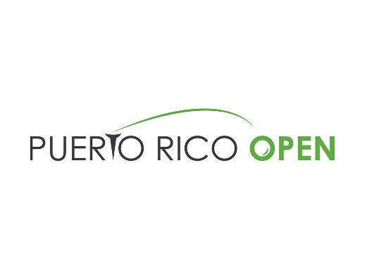

2020 Puerto Rico Open Message Document
Six things to know about the Puerto Rico Open
- PGA TOUR golf in Puerto Rico: Puerto Rico has been a proud host of the PGA TOUR over the last decade and is excited to host the tournament in 2020 and 2021. Established in 2008, and with a one-year hiatus in 2018 to host a charity pro-am for Hurricane Maria recovery, the Puerto Rico Open is stronger than ever as Puerto Rico’s major professional sporting event.
- Springboard to Stardom: Since the tournament’s inception in 2008, the Puerto Rico Open has helped elevate the careers of several PGA TOUR stars with strong play, including the likes of Jason Day, Tony Finau, Jordan Spieth, Brooks Koepka and Emiliano Grillo.
  - In his second season on TOUR, Jason Day finished T2 in Puerto Rico, his best finish in his first 39 starts on TOUR; Day has gone on to win 12 times
  - Tony Finau won his lone TOUR event at the 2016 Puerto Rico Open; since then, Finau has accumulated 28 top-10s, including six runner-ups
  - Past sponsor exemptions include Jordan Spieth (2013) and Brooks Koepka (2014). Spieth earned Special Temporary Membership soon after his runner-up finish in 2013 and was named PGA TOUR Rookie of the Year; He has since won the FedExCup (2015) and accumulated 11 career PGA TOUR wins; Koepka, currently No. 2 in the OWGR, has seven PGA TOUR wins, including four majors
  - Bryson DeChambeau lost in a playoff at the 2017 Puerto Rico Open and went on to win his first PGA TOUR title later that season at the John Deere Classic, his first of now five PGA TOUR titles
  - After finishing runner-up at the 2015 Puerto Rico Open, Emiliano Grillo won the 2015 Safeway Open and was voted PGA TOUR Rookie of the Year
- Discover Puerto Rico: Puerto Rico’s vibrant culture, friendly people and diverse scenery make it a top destination in the Caribbean. The island has received numerous accolades as a top travel destination including CNN’s 2020 “10 of the Best Caribbean Islands to Visit,” Forbes’ “US Travel: 25 Best Places to Visit in 2020” and “Five Hottest Places to Travel in 2020 for your Best Vacation,” as well as National Geographic Traveler’s “Cool List for 2020.” Note: In early January, Puerto Rico experienced an earthquake that affected the southwest coast of the island. Upon evaluation, the region received minor damage and the island continues to operate normally.
- Impact: The Puerto Rico Open and non-profit organization Good Sports, delivered $1 million in sports equipment and monetary contributions to 33 non-profits that benefit thousands of kids in Puerto Rico. The contribution was achieved thanks to Kids Pro Fun, a tournament campaign to positively impact the lives in the community. The campaign, supported by individuals, corporate donors and friends of the PGA TOUR, exceeded its goal, and reached the largest donation and delivery made by Good Sports.
- With this victory: The Puerto Rico Open winner receives 300 FedExCup points, a two-year exemption on the PGA TOUR and an invitation to THE PLAYERS Championship (if not previously eligible) and other select events.
- Puerto Rookie: There has not been a rookie winner through 18 events, the longest stretch to start a season since 2009 when no rookies won the entire season; 16 of the 21 2019-20 PGA TOUR rookies are in the field and three of the last nine winners of the Puerto Rico Open were rookies, including 2019 champion Martin Trainer.

